User Flow

Everyone: sign in and move around
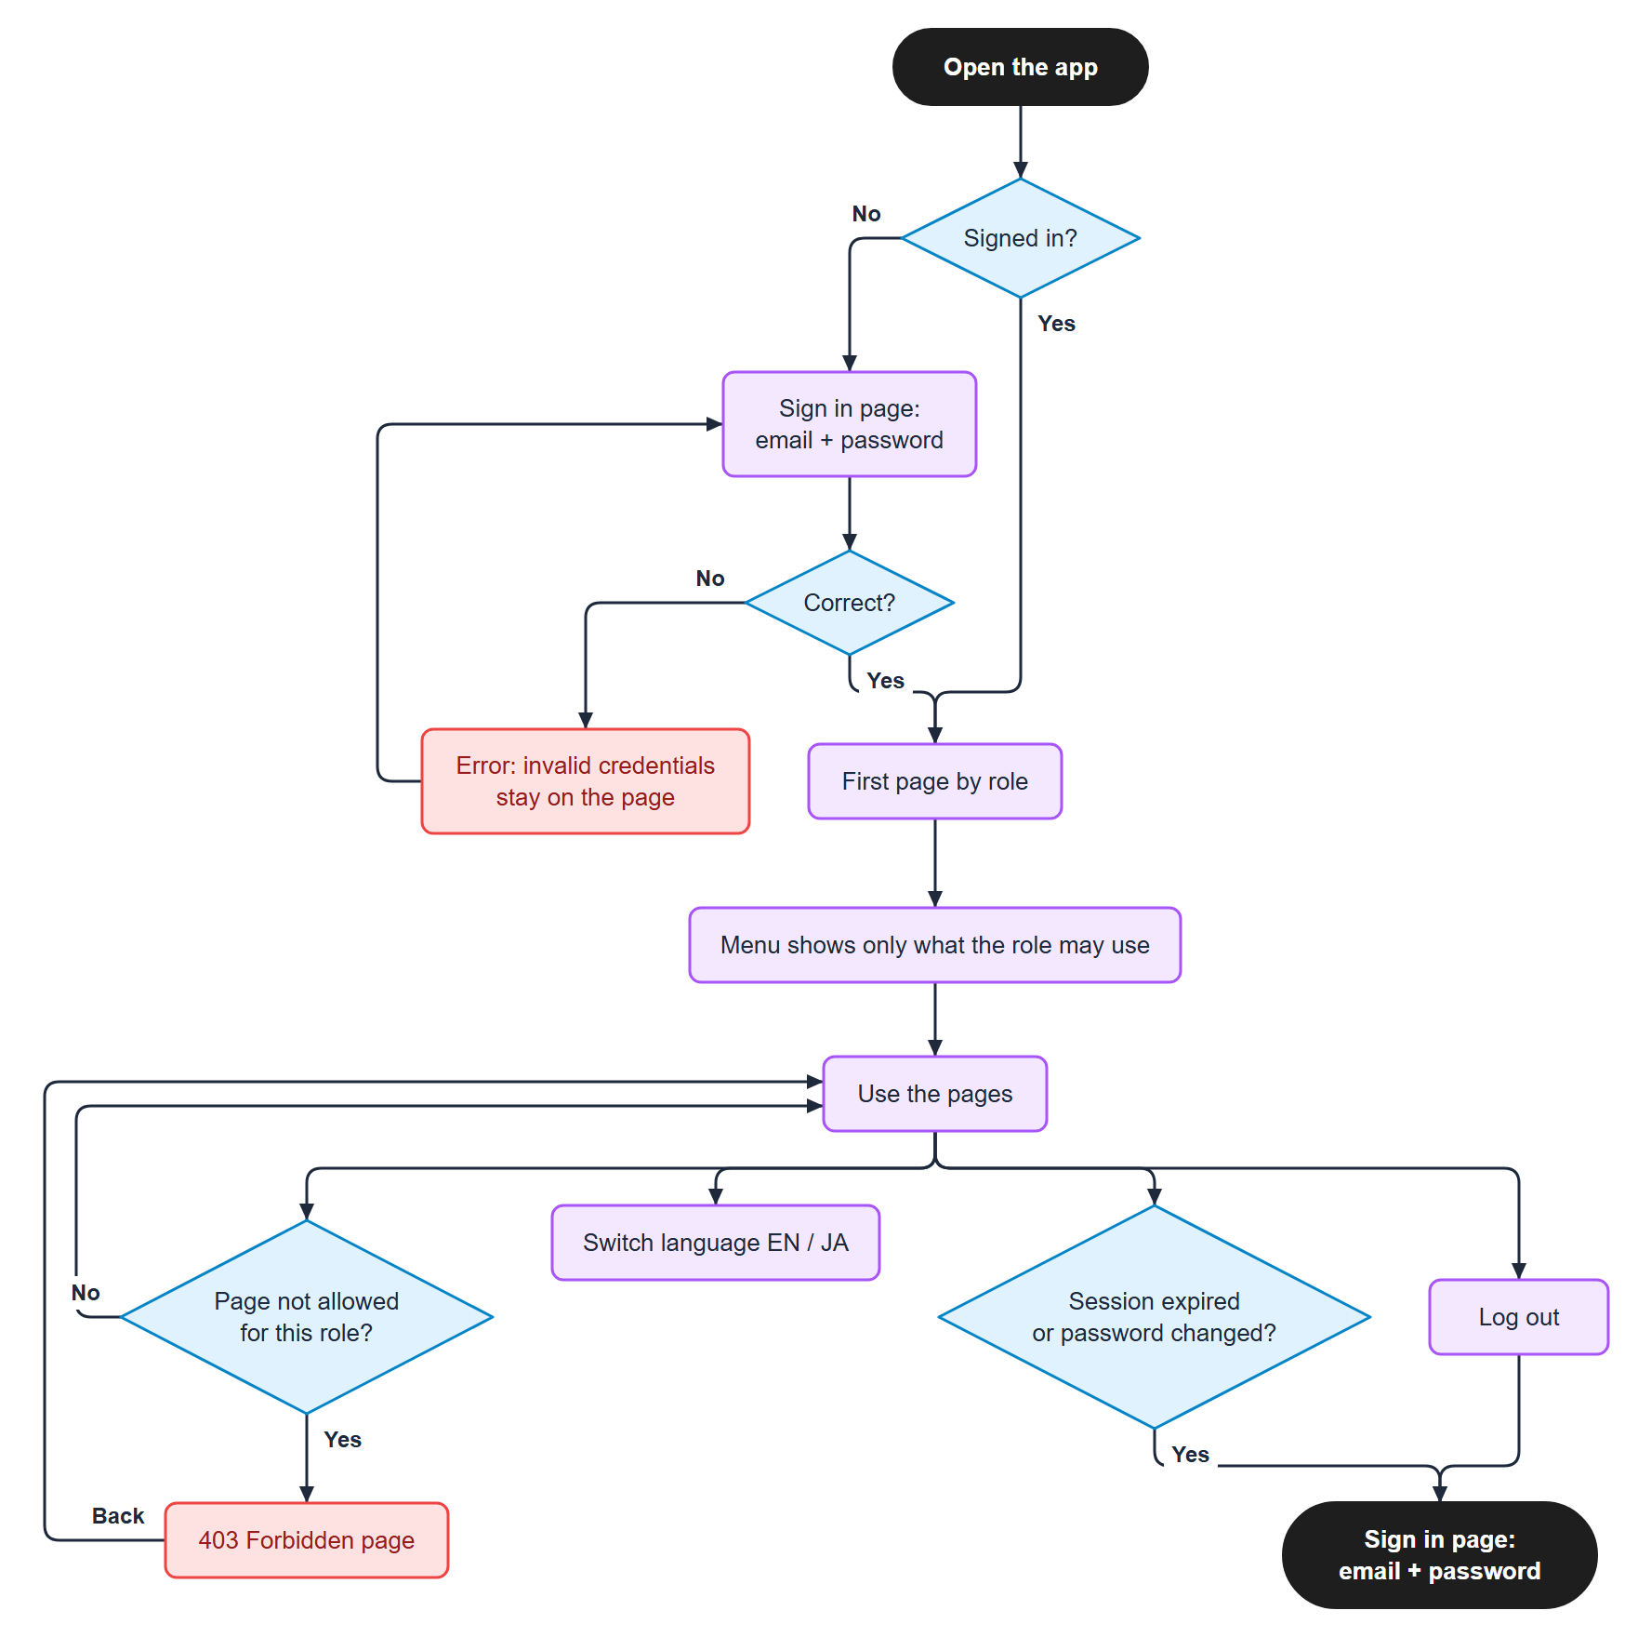
Figure 1. Everyone: sign in and move around

Sale Worker

Pages
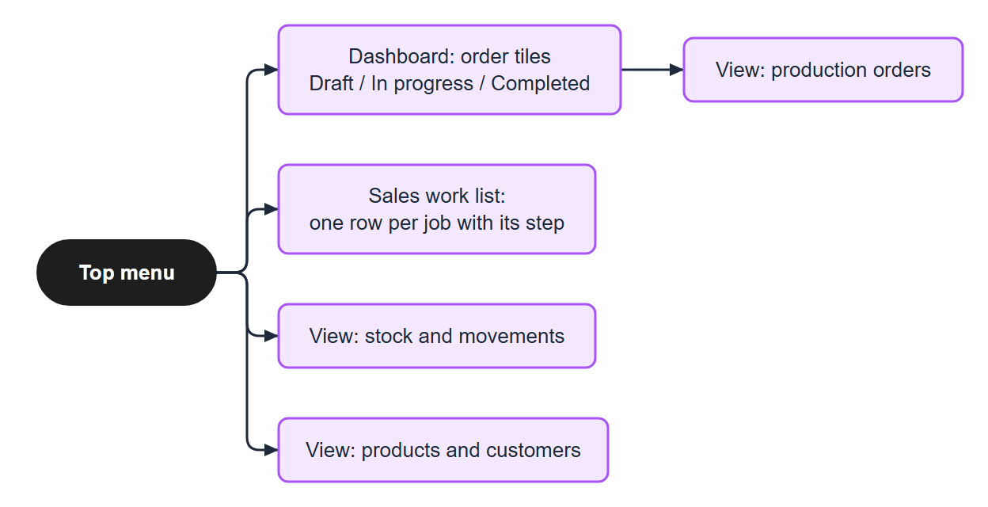
Figure 2. Pages

Make and confirm a QT
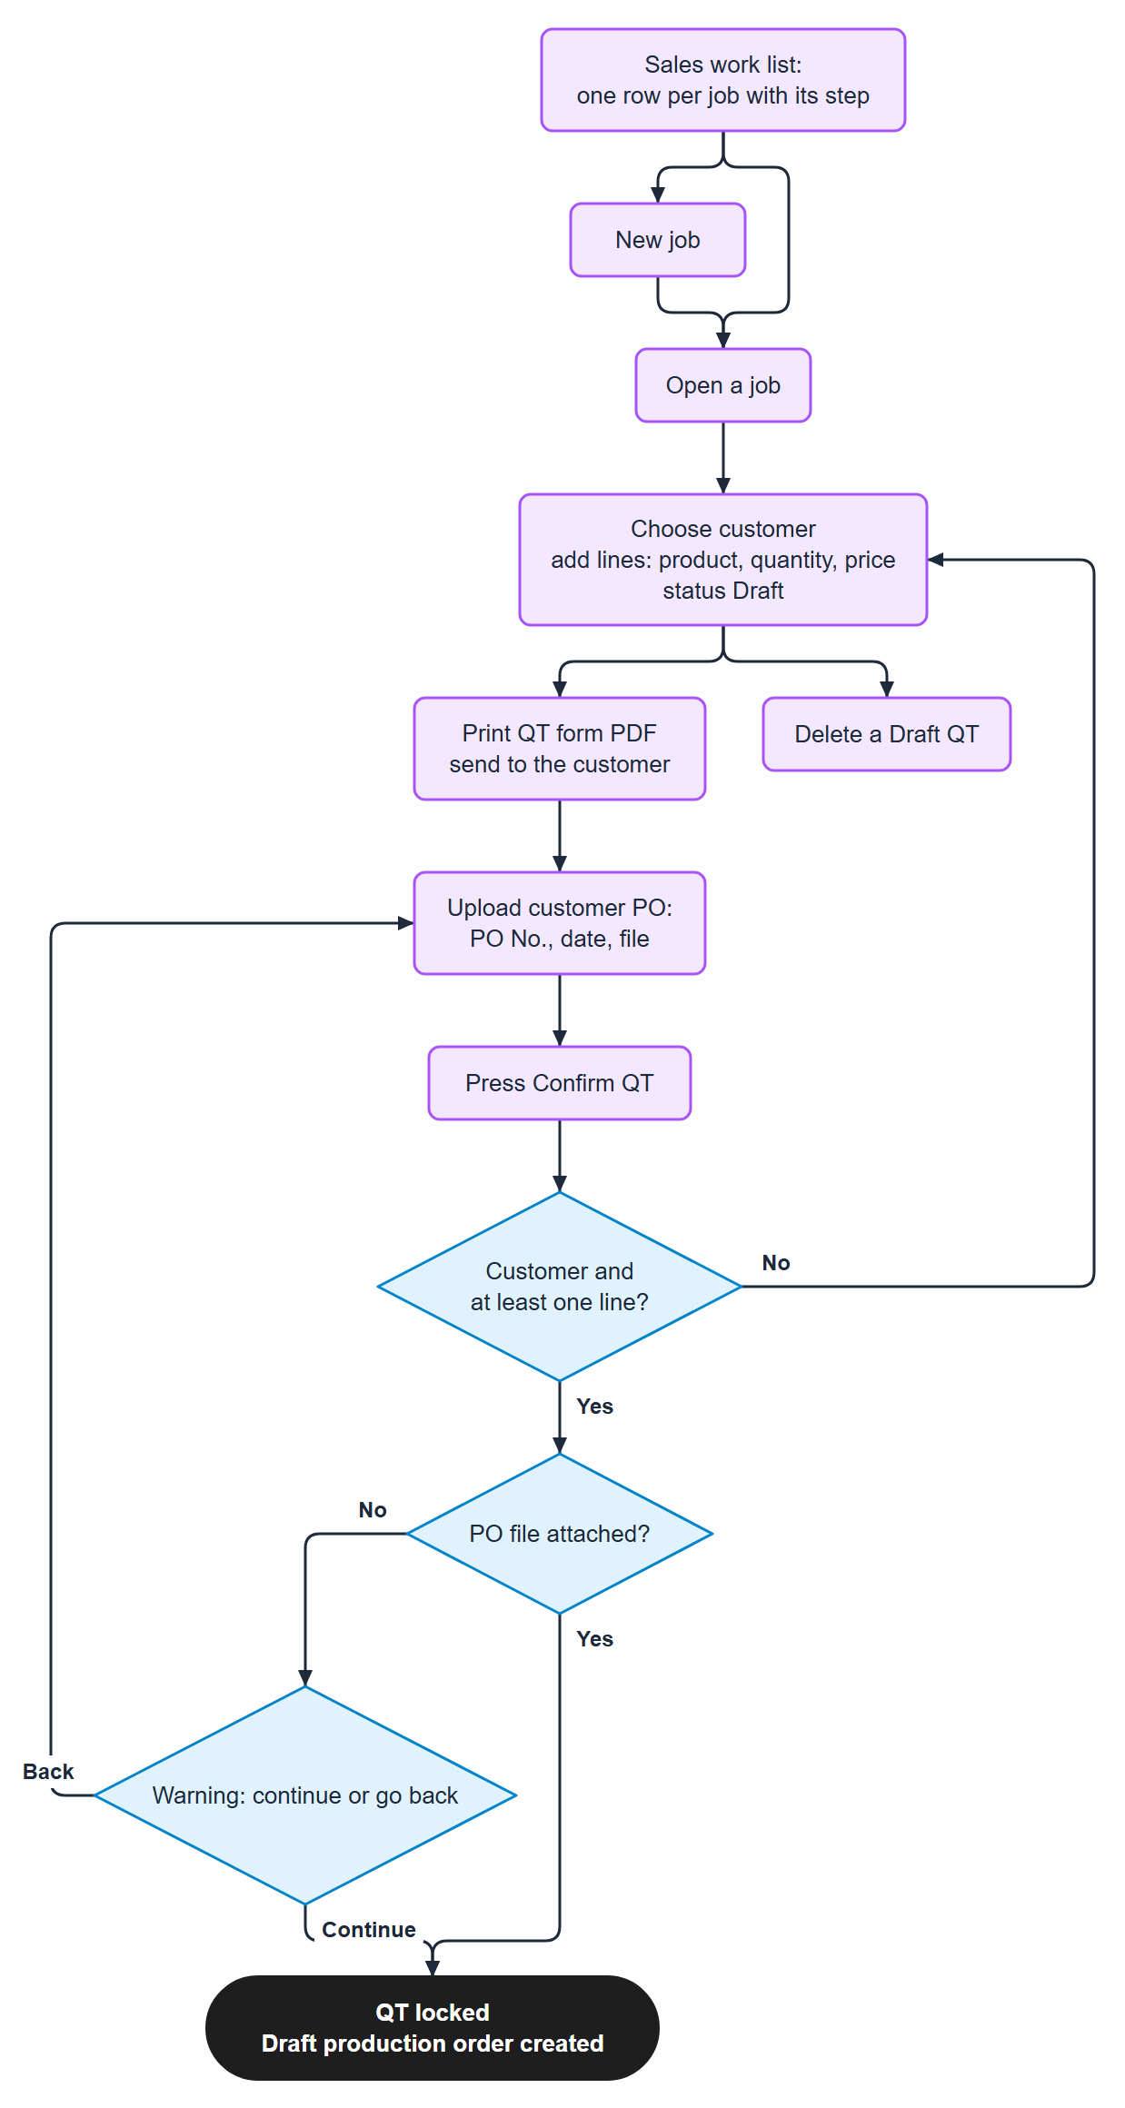
Figure 3. Make and confirm a QT

After Confirm
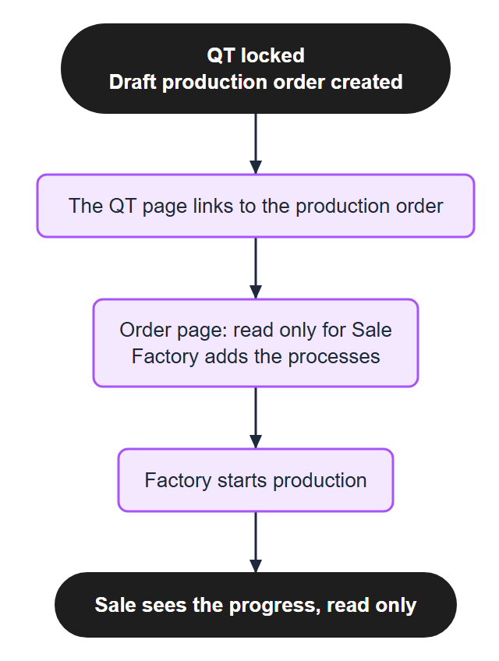
Figure 4. After Confirm

Factory Worker

Prepare and start an order
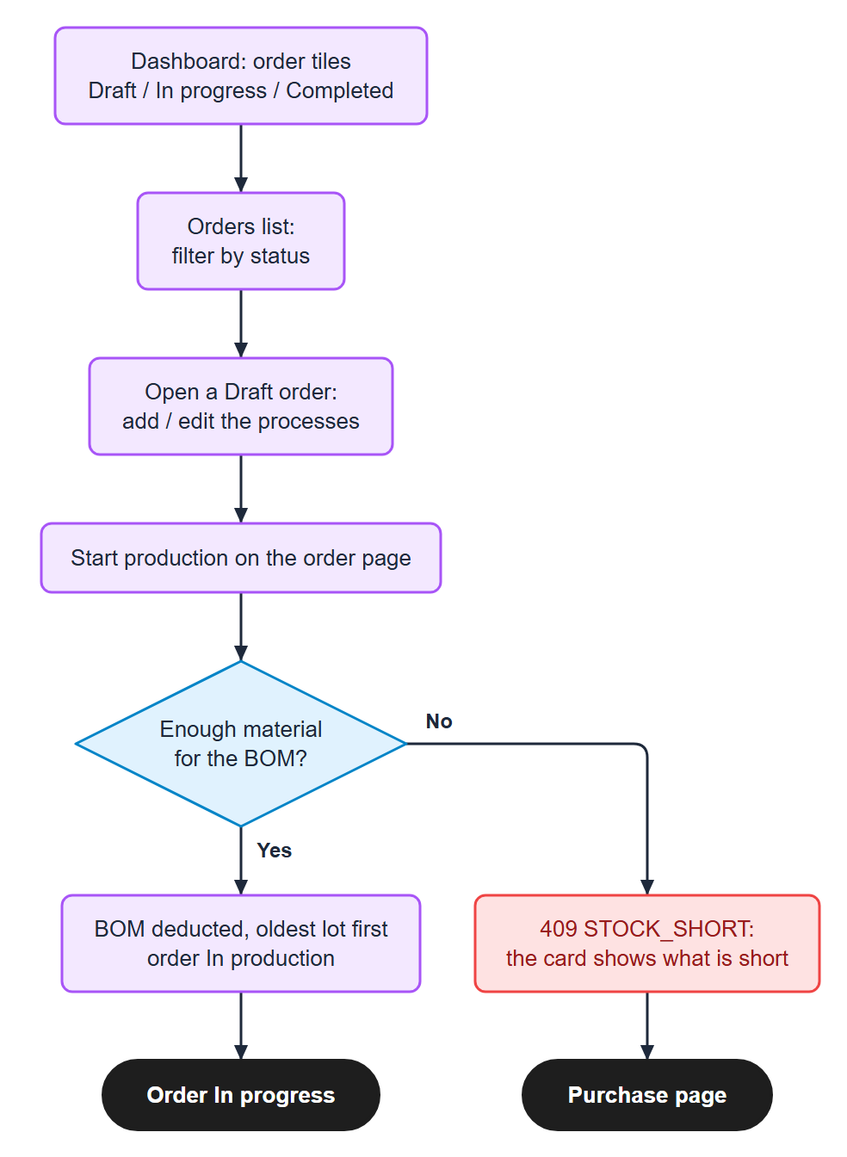
Figure 5. Prepare and start an order

Record progress
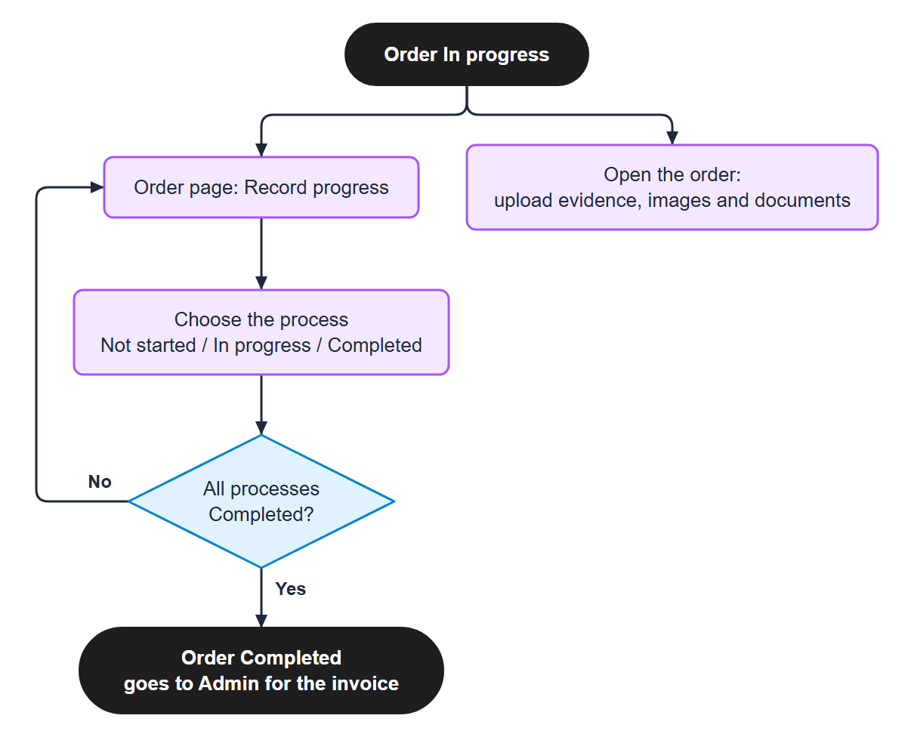
Figure 6. Record progress

Purchase and stock
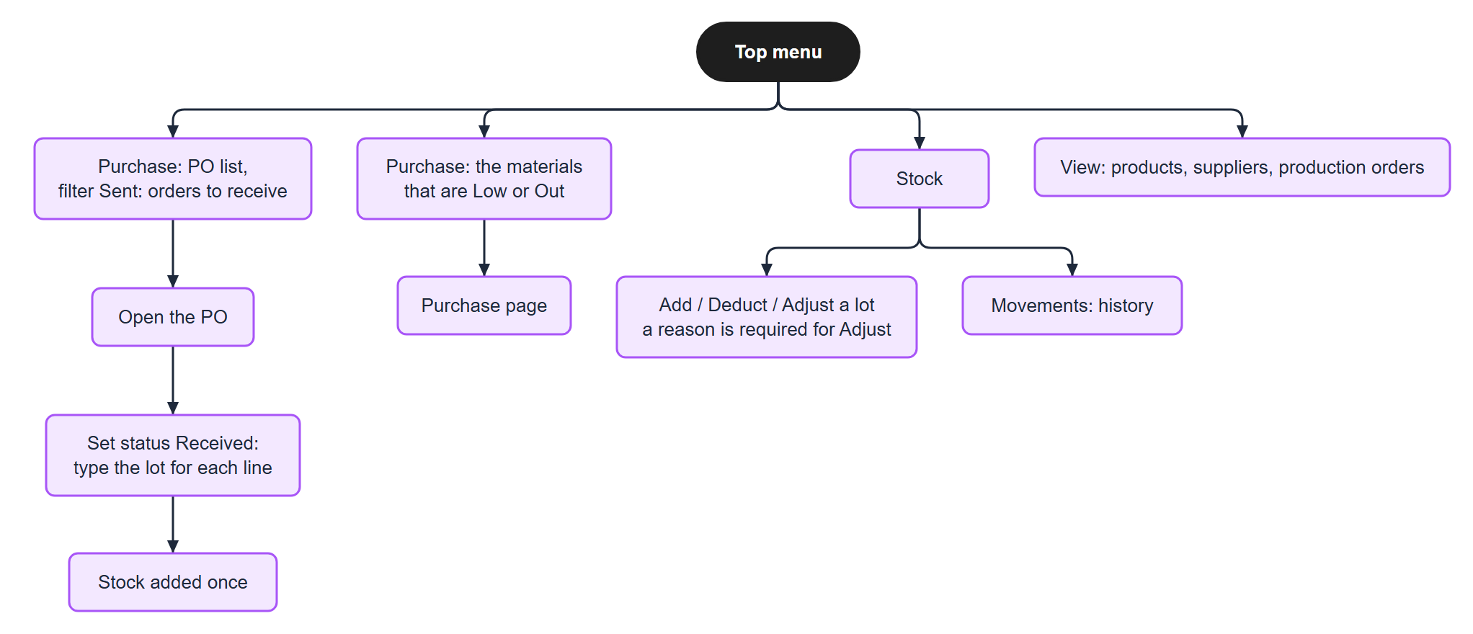
Figure 7. Purchase and stock

Purchase (Factory Worker and Admin)
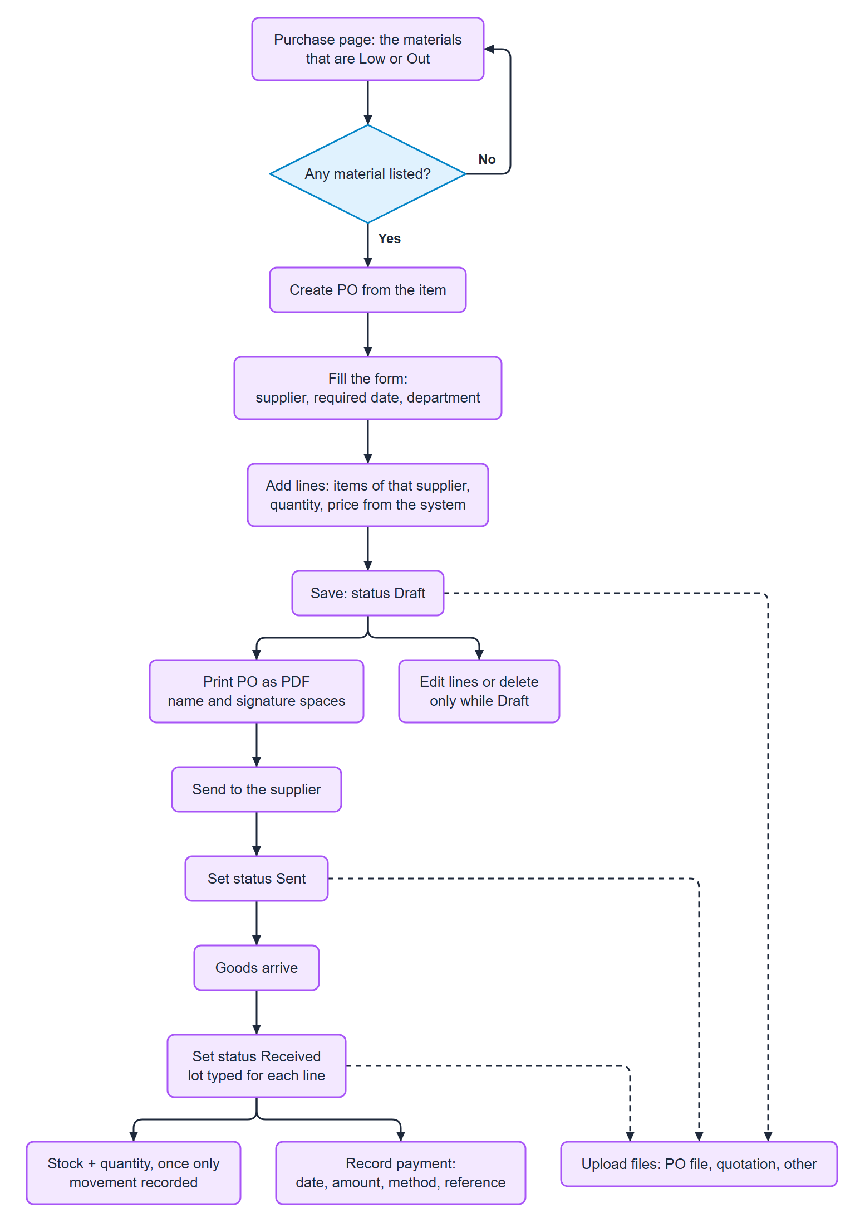
Figure 8. Purchase (Factory Worker and Admin)

Admin
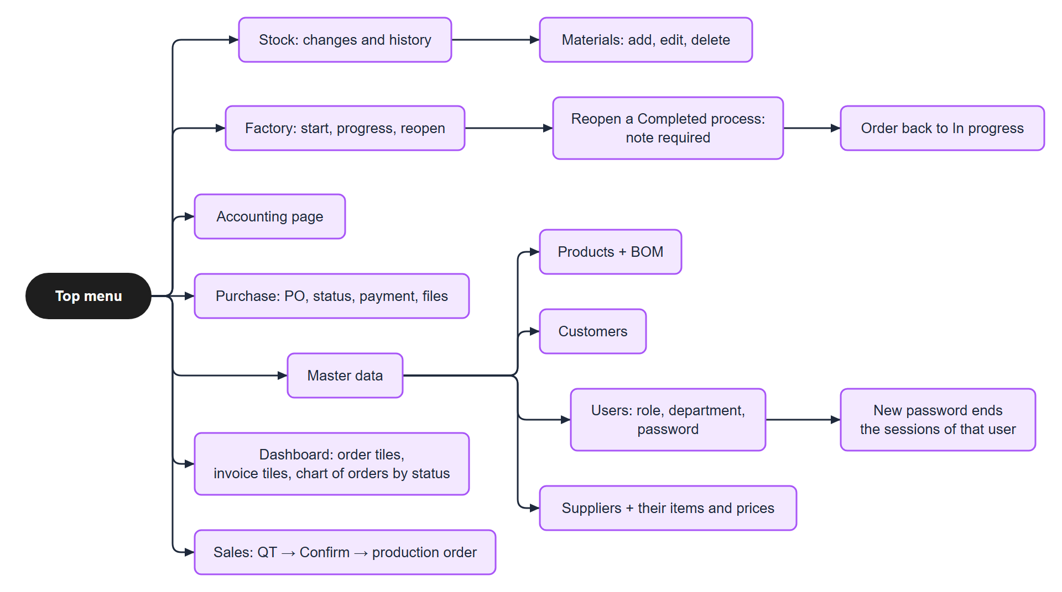
Figure 9. Admin

Admin: accounting
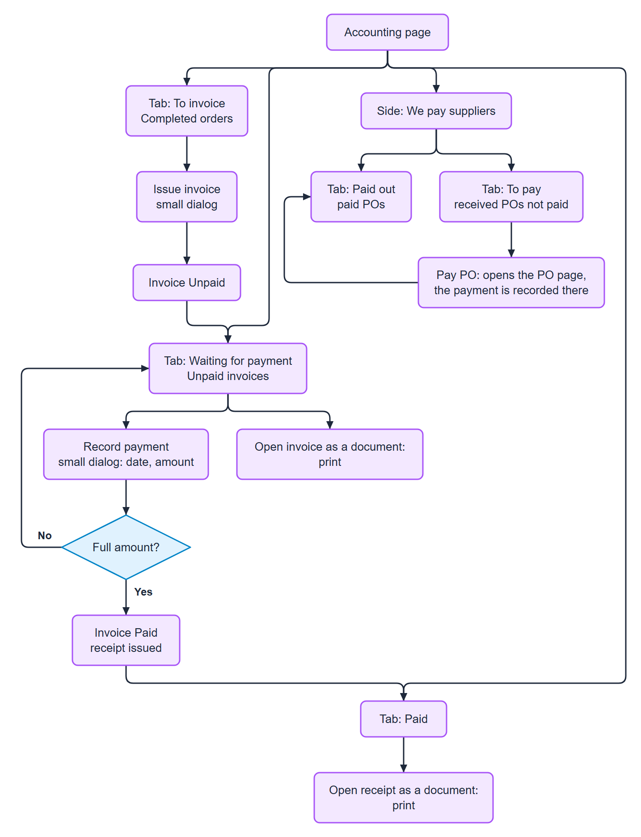
Figure 10. Admin: accounting

Master data
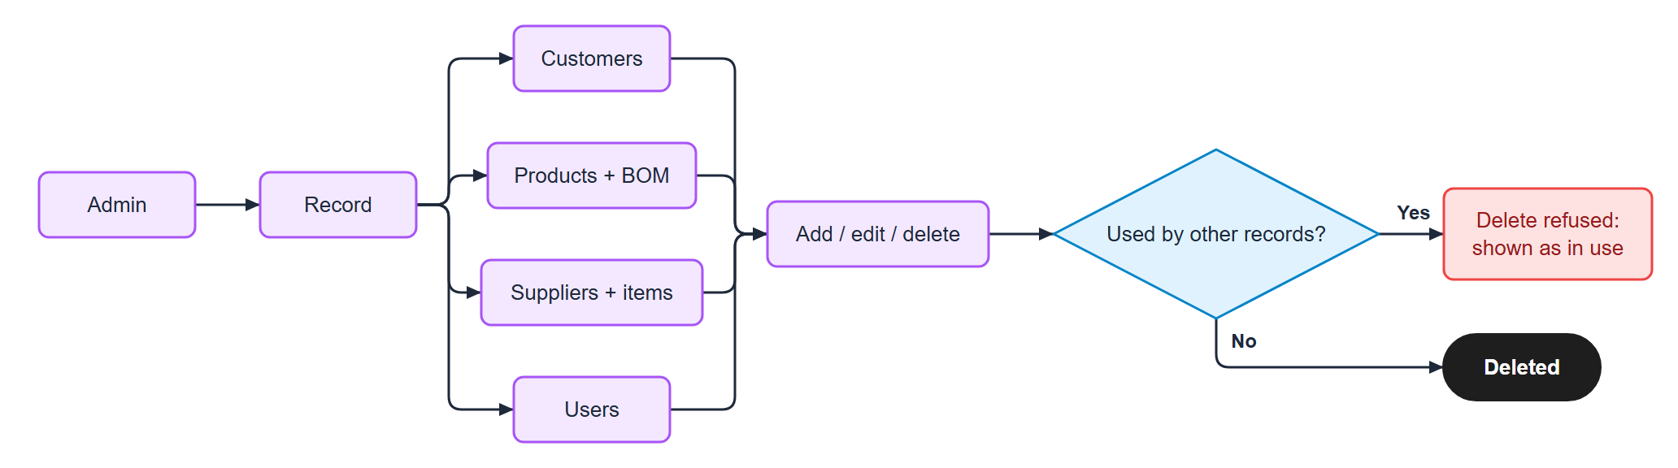
Figure 11. Master data

Print and upload (any page with files)
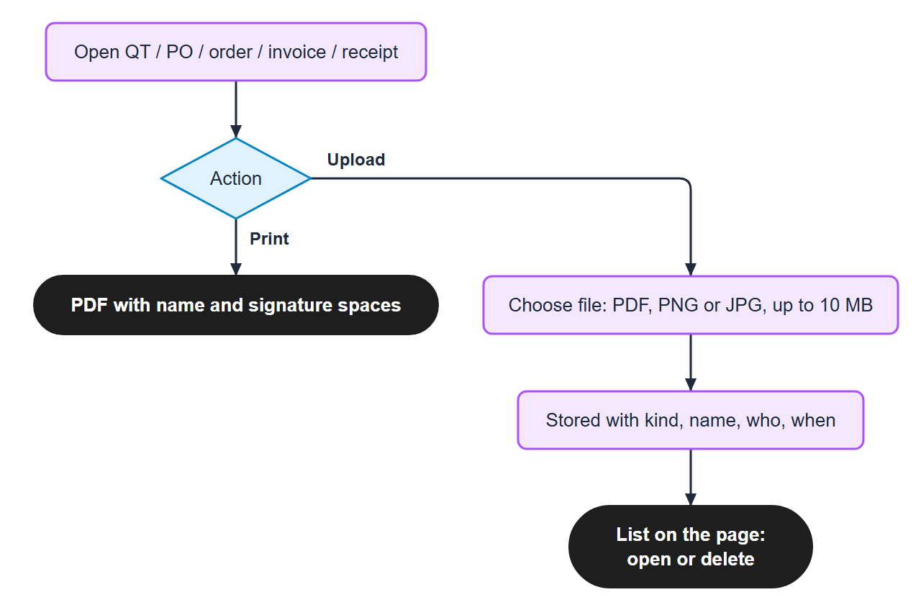
Figure 12. Print and upload (any page with files)

